Name: |  | ___________________________________________________ |  |  |  |  | Date: ___________
 |  | Subject Year 10 MATHEMATICS (Pre Stage 2)  Investigation 3, 2011 (Take Home)  Topic – Transforming Quadratic functions
Total Time: |  |  |  | Penalties (only deducted once in the whole assessment):   Rounding - Incorrect/inappropriate (-1)   Notation – incorrect/missing (-1)   Units - Incorrect/missing (-1)
Weighting: |  | 0% of the year.
Important Information:
Although the take-home component is not worth any marks, it is essential in preparation for the in-class component. Knowledge and skills gained will be extended in the in-class validation component. This in-class validation will be completed under test conditions on the day in which this take-home component is due. The take-home component may be used when completing the in-class component. Contact will be made to parent(s) if the take-home component is not available for submission (at the start of the lesson).

Date out: |  |  | Week ___ Date ____________ |  | Date Due: | Week ___ Date _____________
Take home component weighting: |  |  | 0% of the year |  | In-class component weighting: | 4% of the year.
AIM:
In this assessment, you will be investigating change in position and shape of parabolas with respect to changing coefficients.
Read the information below carefully before starting the investigation questions.

What is a quadratic function?
A quadratic function is one that has a constant second difference pattern and forms a parabola when graphed.
A quadratic function can be expressed in three formats:
- y = ax² + bx + c is called the general form,
- y = (x-a) (x-b) is called the factored form.
- y = a (x- h) ² + k is called the vertex form (or standard form), where h and k are the x and y coordinates of the vertex (or turning point), respectively
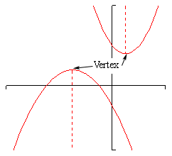

Transformations
Transformation: A graph is said to have transformed if it has altered through a transformation process.

The three main types of transformations are:

- Rotation

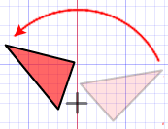

- Reflection

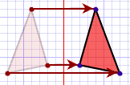

- Translation

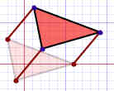
Resizing

The other important Transformation is resizing (also called dilation, contraction, compression, enlargement or even expansion). The shape becomes bigger or smaller.

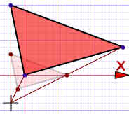

1. | Investigate the changing the value of “a” in y = ax²
Complete the following table of values and draw the respective parabolas in the same X-Y plane (graph) given:

y = x²

x | -3 | -2 | -1 | 0 | 1 | 2 | 3
y

y = -1x²

x | -3 | -2 | -1 | 0 | 1 | 2 | 3
y

y = 2x²

x | -3 | -2 | -1 | 0 | 1 | 2 | 3
y

y = 4x²

x | -3 | -2 | -1 | 0 | 1 | 2 | 3
y

y = 0.5x²

x | -3 | -2 | -1 | 0 | 1 | 2 | 3
y

Display all five quadratic functions on the same axis provided below.
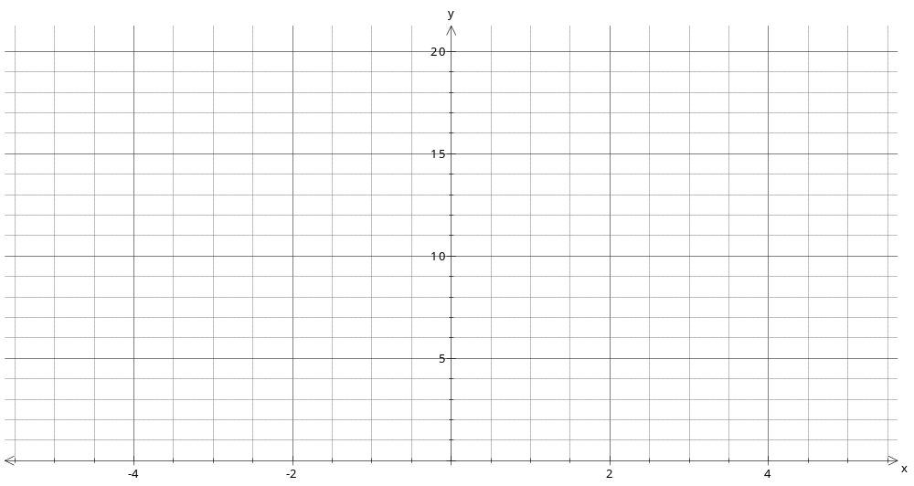How does the graph of y = ax² vary from that of y = x²?

2. | Investigate the value of “c” in y = x² + c
Complete the following table of values and draw the respective parabolas in the same X-Y plane (graph) given:

y = x²

x | -3 | -2 | -1 | 0 | 1 | 2 | 3
y

y = x² + 2

x | -3 | -2 | -1 | 0 | 1 | 2 | 3
y

y = x² + 4

x | -3 | -2 | -1 | 0 | 1 | 2 | 3
y

y = x² - 3

x | -3 | -2 | -1 | 0 | 1 | 2 | 3
y

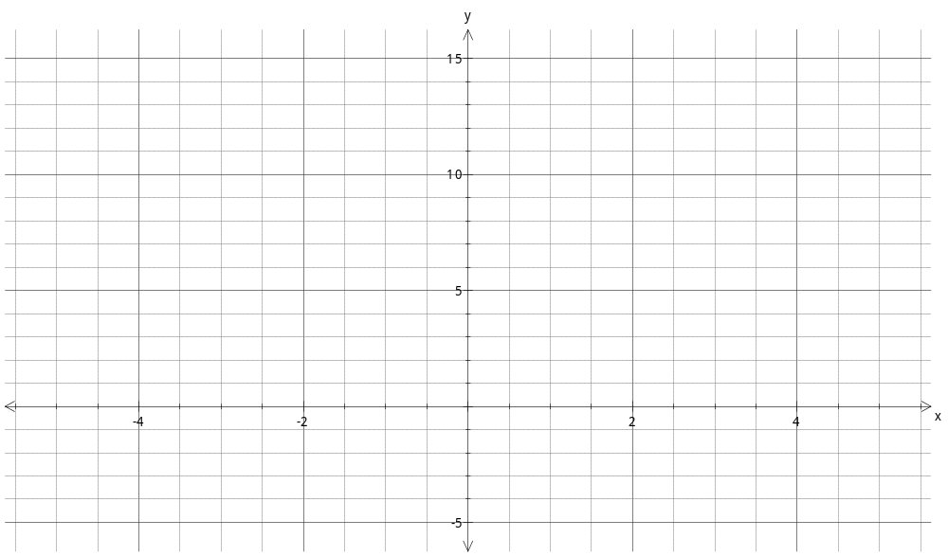
How does the graph of y = x² + c vary from that of y = x² as c varies?

3. | Investigate the value of “b” in y = (x – b) ²
Complete the following table of values and draw the respective parabolas in the same X-Y plane (graph) given:

y = x²

x | -4 | -3 | -2 | -1 | 0 | 1 | 2
y

y = (x + 3) ²

x | -4 | -3 | -2 | -1 | 0 | 1 | 2
y

y = (x + 5) ²

x | -4 | -3 | -2 | -1 | 0 | 1 | 2
y

y = (x - 2) ²

x | -2 | -1 | 0 | 1 | 2 | 3 | 4
y

y = (x – 5) ²

x | -2 | -1 | 0 | 1 | 2 | 3 | 4
y

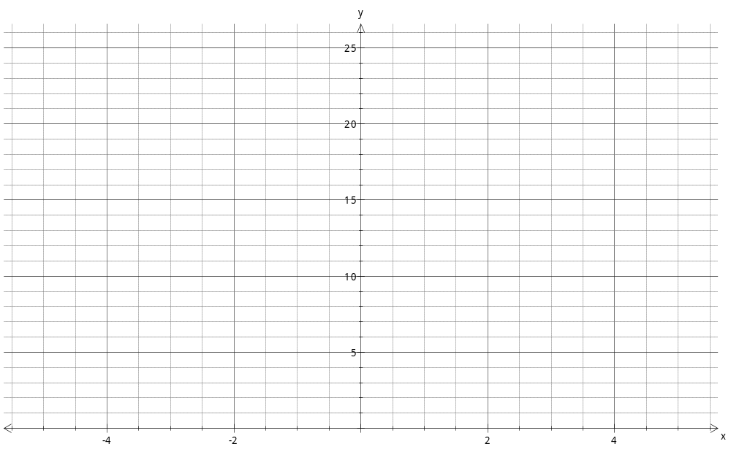
How does the graph y = (x – b) ² vary from y = x² as b varies?

